Best practice - II 2019-20

Title of the Practice: Promotion of universal values among students.

Objectives: To inculcate human universal values in students, in fulfillment of realization of the moto of the institute.

Context:

In today’s world, where the majority of the people are pursuing only self-interests
relentlessly, the institution recognizes the need to inculcate universal values like
the promotion of truth, selflessness, righteousness, etc. Our college is working toward this goal.

The practice:

To provide a common code of conduct that can bring in,
• harmonious development of body, mind, and soul and promotion of universal values.
• Cultivate inner calmness “a way to peace”.
• Shed selfishness and learn to help others.
• Practice truthfulness.
• to deal with academic and emotional stress by tapping their inner sources of strength.
• to develop a positive attitude

The college has organized the following activities.
• A special lecture on values as perceived by Personality Development and Yoga was held on 15.11.19.
• Programme on the importance of Democratic Institutions and students’ Awareness of a vote, was held on 25.01.19.
• Psychological counseling of girl students in commemoration of Women Empowerment held on 12.10.19.

• A program on the promotion of universal values by World Human Right Day 06.04.19.

Evidence of Success:

Students are increasingly taking interest in this practice. They are regularly attending these classes despite their schedule of usual classes.

Problems encountered Resources Required:

No serious problems here encountered, but some of the following difficulties were experienced:
a) Resource persons are reluctant to come to this area, which is about 60Km from the district headquarters.
b) Financial resources need to be strengthened to invite prominent personalities to speak on the subject.

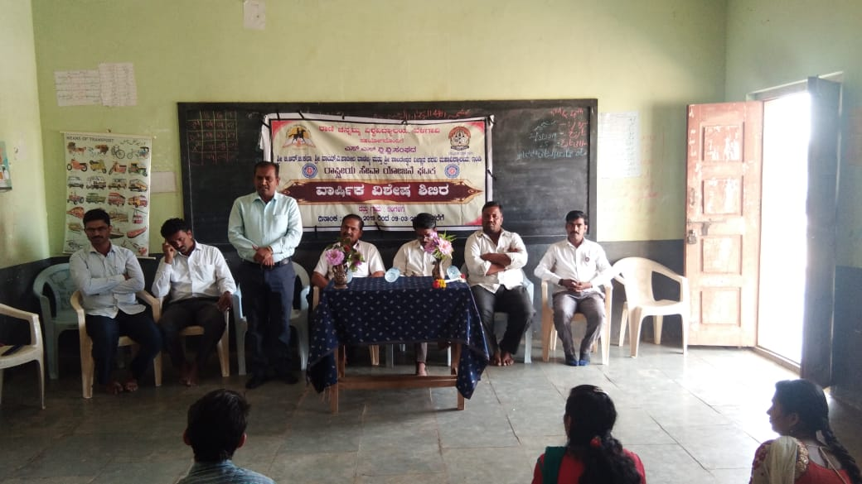

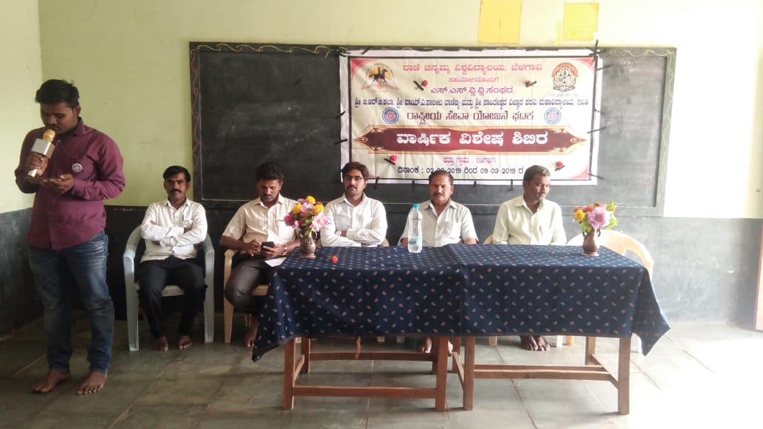
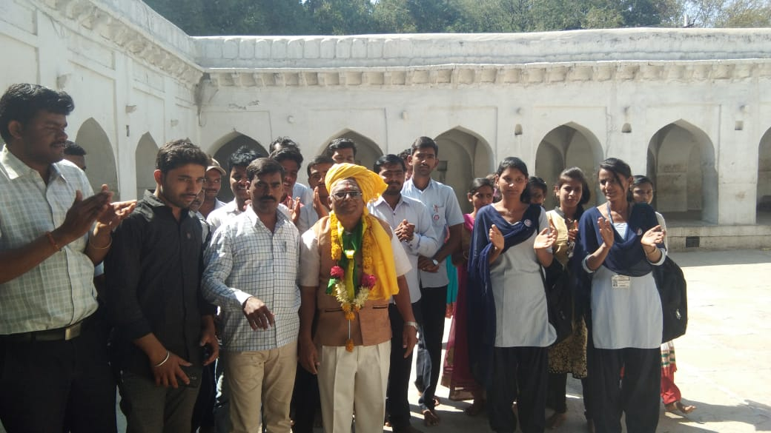

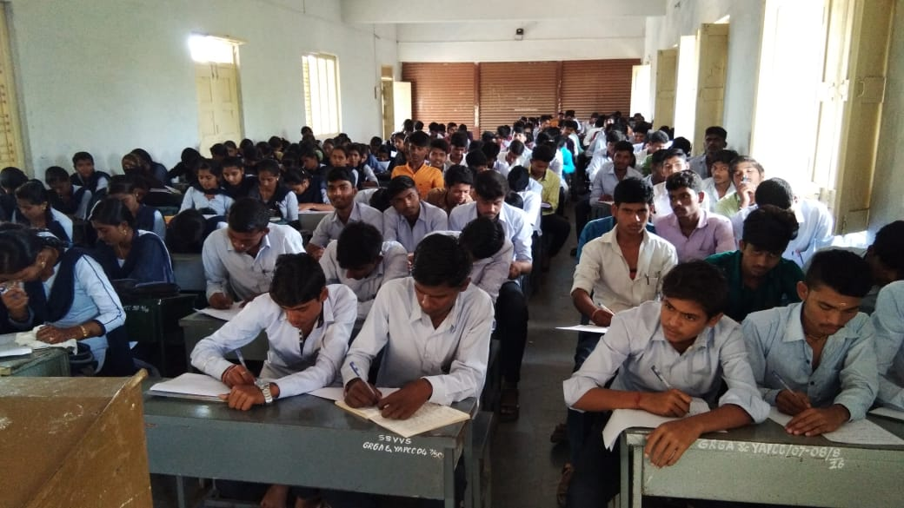

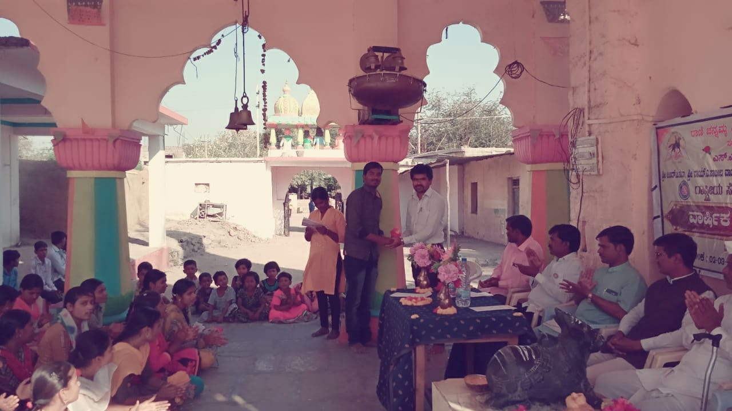

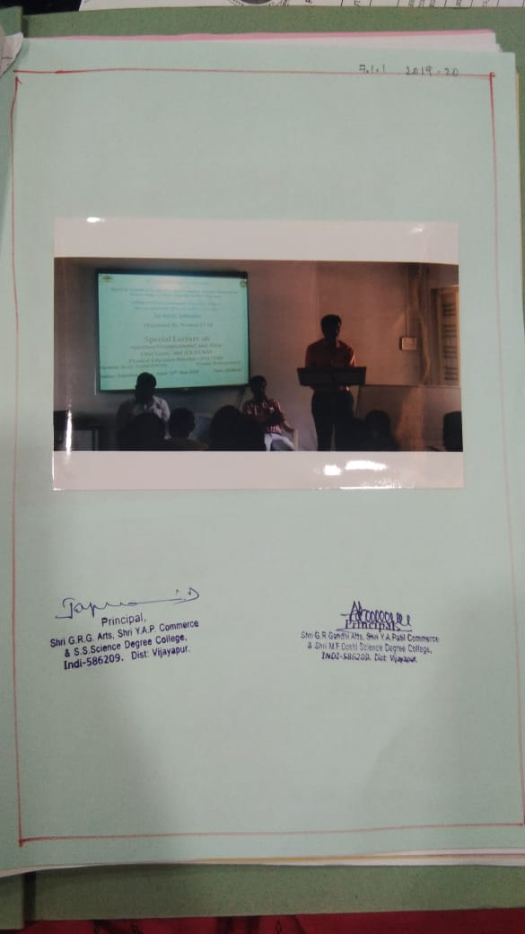

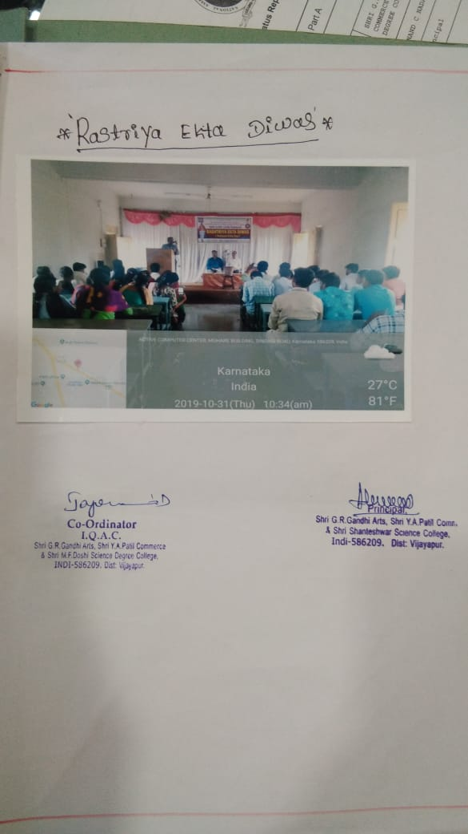

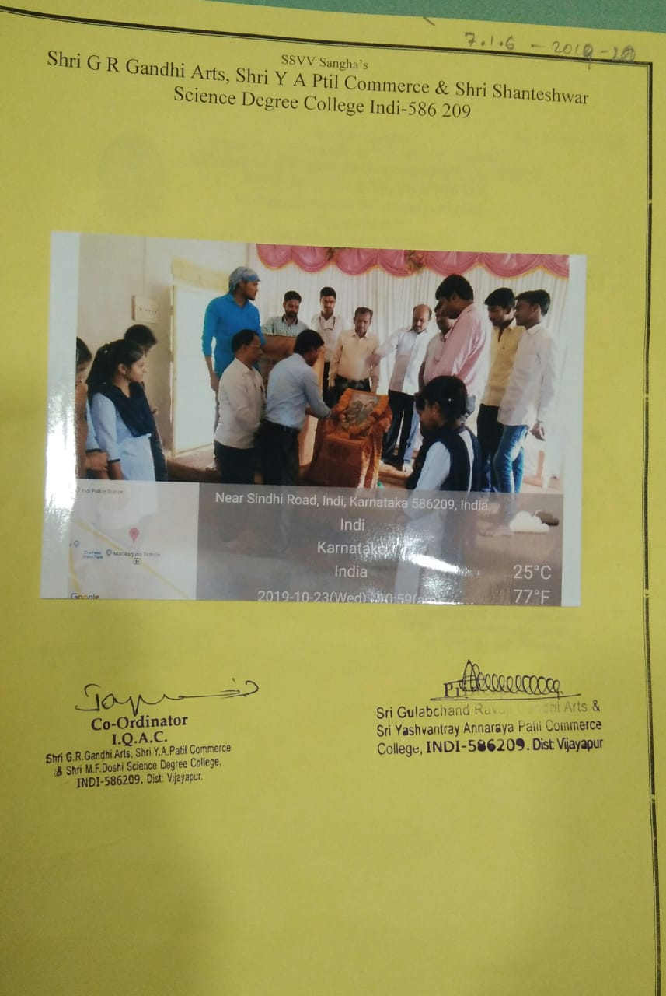

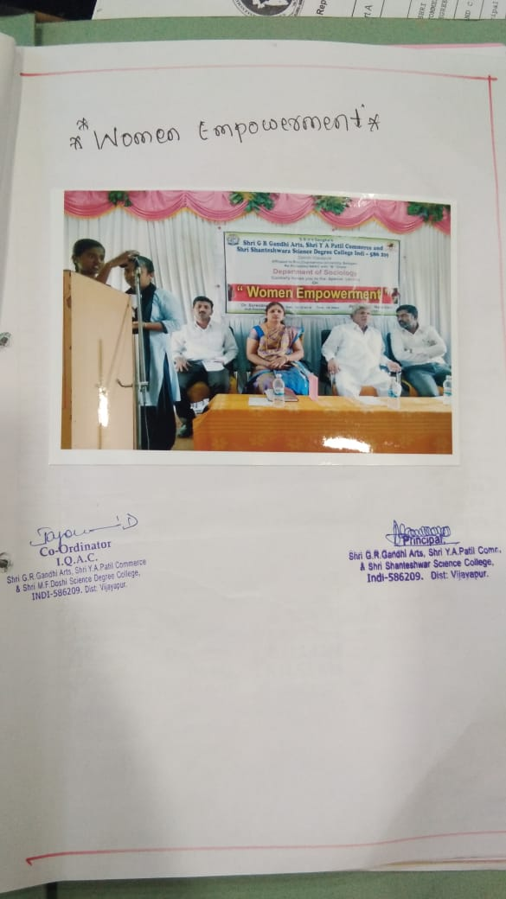

Best practice - I 2019-20

Title of the Practice: The morning prayer is the best practice.

Objectives of the Practice:

To create cultural habits among the students. To maintain discipline. To keep the mind and the soul peaceful. Prayer is conducted everyday morning to mold the students to give spiritual value. Prayer enhances team spirit, self-confidence, and leadership quality and strengthens personality.

Context:

A committee has been formed to monitor the prayer so that individual attention of the students is encouraged. Both students and teachers are important participants in the occasion of prayer. It is conducted to provide opportunities for the student to plan prayer gatherings and execute the prayer. The college focuses on unity and team-building quality through prayer by the students. The prize winners of various competitions in sports and cultural activities are appreciated in the prayer assembly for enhancing their positive attitudes. News of the day read on the day to enrich students’ general knowledge.

The practice:

Every day, prayer sessions are organized to improve the quality of education. The prayer committee guides and encourages students to plan and conduct prayer on a regular basis. It is better to conduct the prayer, department-wise every day. A minute of silence is observed to create the prayer program, department wise every day. A minute of silence is observed to create calmness and a sense of integrity is developed. The habit of reading is developed among the students. The principles of self of the day-- discipline and confidence are inculcated the students are informed about daily activities and they are regularized in their academic work. The practice of prayer improves attitudes towards a sustainable lifestyle.

Evidence of Success:

The prayer assembly offers opportunities for the students to improve communication skills and remove the stage of fear. The prayer supports the students to have a calm and reflective mood. Prayer creates a sense of pride in the students. It instills self-confidence. It molds students to have a friendly approach with neighbors, family members, and society also prayer and a sense of togetherness are developed. Through prayer, moral, social, and spiritual values are inculcated successfully. Thus, we inculcate the spirit of harmony among all religions in the young minds of the students.

Problems encountered Resources Required:

Conducting the prayer on the college ground by keeping the students and staff members stand will create health problems like leg pain and giddiness. Adverse climate conditions also may affect the participants. Hence make the students stand in shadow and conduct the prayer for a maximum of five to ten minutes. If the prayer is prolonged make the students sit on the ground. assuring the utmost Specific Facilities Provided For Ladies

DAILY PRAYER
